Directions for Students to login to their new TAO V3 accounts:

1. Navigate to the Login Link: <https://us.taoconnect.org/login>
2. Enter your UCR Email Address
3. Click Next, You will see:

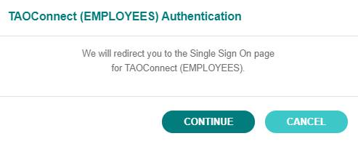

1. Login with your UCR credentials
2. If you HAVE NOT verified your email yet, you will see:

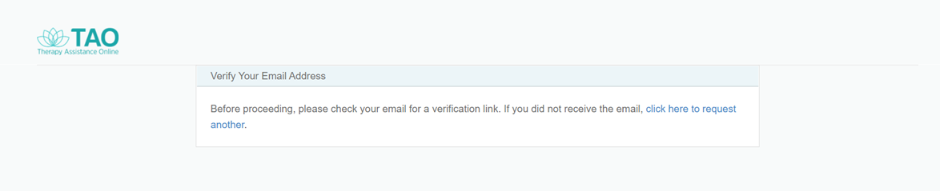

1. Click the blue hyperlink: “click here to request another.”
2. You will receive this email:

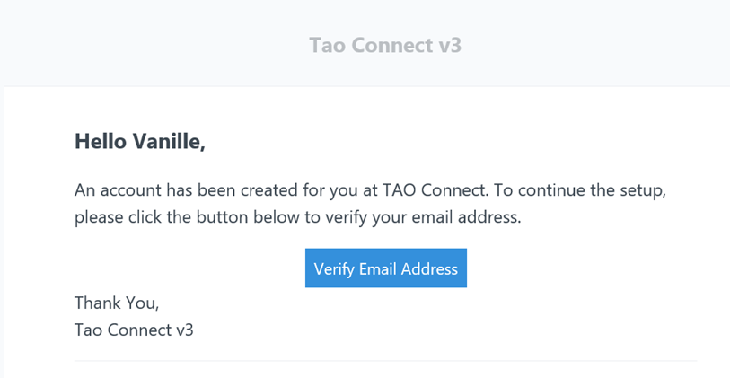

1. Click the blue Verify Email Address button and you will be redirected to TAO.

To access Videoconferencing, select videocamera icon from your homepage once logged in (see sample page below).

